

3/18/2021



**NAME: (PC) Amina Qadeer**

**Class: CE-42-A**

**ROLL #: 359607**

**SUBJECT: Computer programming**

**TEACHER: Ma’am Rimsha**

ASSIGNMENT# 1

QUESTION 1: WHAT IS A PROGRAM?

ANS:

A program is basically a set of instructions (guide), that computer follows in order to perform a specific tasks. A programmer writes a code, programming language is a special language that is used to write programmes. Programming is to make machines work.

QUESTION 2: WHAT ARE VARIABLES? GIVE BRIEF DESCRIPTIONS?

ANS:

A variable is an item of data that is given a name and a data type and is stored in a computer’s memory for the later use in a program.

Variables can be used to store a variety of data of different data types. For example:

**Variable types**

* 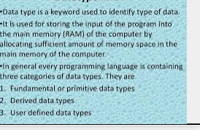Integers
* Characters
* Boolean
* Float
* Double
* single

QUESTION 2: WHAT IS A DATA TYPE?

ANS:

A data type is type of data.

A data type is data storage format that can contain a specific type or range of values. Data type is a key word used to identify type of data.it is used for storing the input of thre program into the main memory (RAM) of the computer by allocating sufficient amount of memory space in the main memory of the computer.

In general every programming language is containing three categories of the data types. They are:

1. fundamentals or primitive data types
2. derived data types
3. user defined data types

QUESTION 2: WHAT ARE STEPS TO MAKE A PROGRAME EXECUTABLE?

ANS:

1. define the problem to solve
2. design and think for the solution by analysis
3. write a code that solves the problem
4. compile the program
5. remove errors if any
6. link objects files
7. test program 8.debug

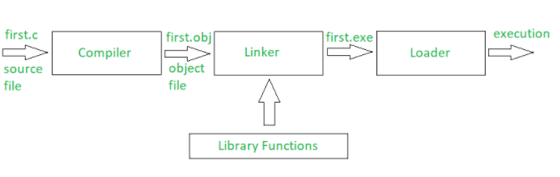

COMPOENETS:

1. Memory. Most modern computers use byte-addressable memory, meaning that each memory address contains 8 bits of data. ...
2. Data Registers. ...
3. The Program Counter (PC) ...
4. The Instruction Register (IR) ...
5. The Control Unit (CU) ...
6. The **Arithmetic** and Logic Unit (ALU)

QUESTION 2: WHAT IS DIFFFERENCE BETWEEN VOLATILE AND NON-VOLATILE MEMORY?

[Memory](https://pediaa.com/difference-between-memory-and-storage/#Memory)is an important component in a computer. There are two types of memory called volatile and non-volatile memory. Volatile memory requires a consistent power flow to hold data. Thus, the content is deleted when the power is interrupted. Therefore, volatile memory stores data temporarily. Moreover, it refers to primary storage such as RAM. On the other hand, non-volatile memory refers to secondary storage devices. This type of memory does not require a consistent flow of power to hold data. In other words, interruption in power will not delete the content in non-volatile memory.

## What is Volatile Memory

Volatile memory requires a continuous flow of power to hold data. Therefore, it will retain data as long as there is power. If there is a power failure, the stored data in the volatile memory is erased. Main memory or **RAM** uses volatile memory. There are two types of RAM called [Static RAM (SRAM)](https://pediaa.com/difference-between-sram-and-dram/#SRAM) and [Dynamic RAM (DRAM)](https://pediaa.com/difference-between-sram-and-dram/#DRAM).

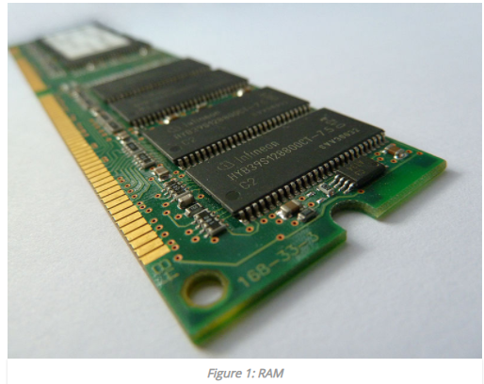

## What is Non-volatile Memory

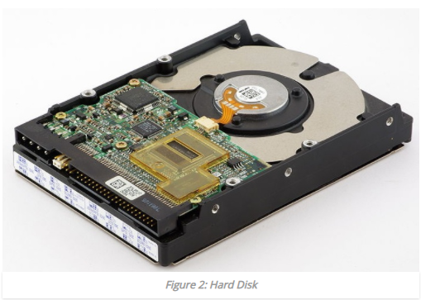The non-volatile memory stores data even there is no continuous power flow. It will retain data even there is a power failure. In other words, the data in non-volatile memory is permanent. ROM, hard disk drives are some examples for non-volatile memory.

**ROM** stands for Read Only Memory. It contains the instructions necessary to start the computer. It is only possible to read from ROM, and it is not possible to do write operations to the ROM.



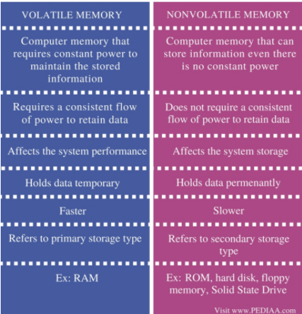

QUESTION 2: WHAT IS CACHE MEMORY?

Cache memory is basically also called CPU memory , is a high speed memory that a computer can access more quickly than it can access to random access memory (RAM).This memory is typically integrated in to the CPU chip. The main purpose of cache memory is too store program data and instructions and data that are used repeatedly in operation of programmes or information CPU is likely needed next.

The cache is a very high speed, extensive piece of memory, which is used to speed the memory retrieval process. Due to its higher cost, the CPU comes with a relatively small amount of cache compared with main memory.

Without cache memory, every time the CPU request for data, it would send the request to the main memory which would then be sent back across the system bus to the CPU. This is a slow process. The idea of introducing cache is that extremely fast memory would store data that is frequency accessed and if possible the data that is around it. This ia to achieve the quickest possible response time to the CPU.

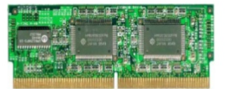

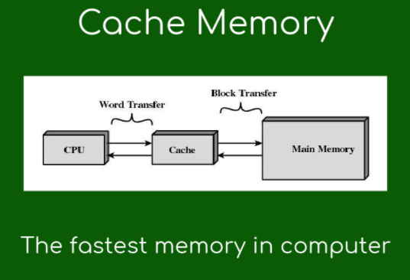

**QUESTION 2: WHAT IS MAIN MEMORY?**

**Ans:**

(Main memory) Primary memory holds only those data and instructions on which the computer is currently working.

* It has a limited capacity and data is lost when power is switched off.
* It is generally made up of semiconductor device.
* It is working memory of the computer.
* Faster than secondary memories.
* 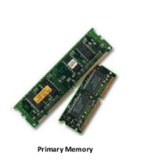It is divided into two subcategories RAM and ROM.

**QUESTION: WHAT IS DIFFERENCE BETWEEN INPUT OUTPUT DEVICES?**

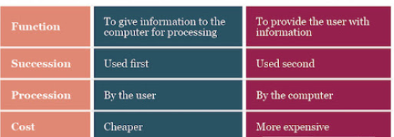

INPUT DEVICES:

Input devices serve the computer user to enter data into the computer. We can say that these are the devices that translate human comprehensible [content](http://www.differencebetween.net/miscellaneous/difference-between-subject-matter-and-content/) into a form suitable for computer processing, or devices that digitize data. 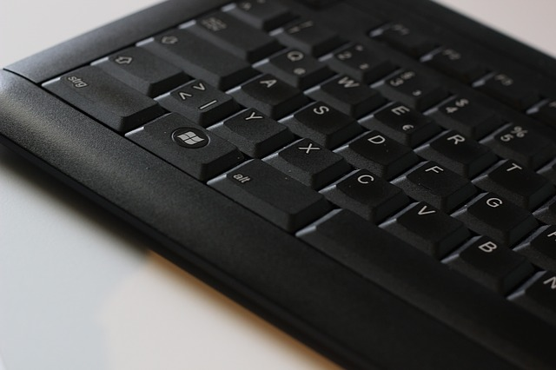

OUTPUT DEVICES:

Output devices allow the computer user to see the work results of the computer. These are devices that translate data from a binary form (a record from zero and a one) into a user’s understandable form (image, letter, sound etc.). Output devices are data processing results indicators in the computer and can be a single light indicator (either on or off),

## http://cdn.differencebetween.net/wp-content/uploads/2018/03/Difference-Between-Input-and-Output-Device.png

## Difference between Input and Output Device

### Purpose of Input and Output Device

Input devices are devices that serve to enter data into a computer. Output devices serve to read some data from a computer. Output devices give the computer the ability to provide us with necessary information.

### Common devices for Input and Output Device

Most often used input devices are the keyboard, mouse, webcam, scanner and microphone. Output devices typically include the monitor, speaker and printer.

### Interaction of Input and Output Device

Input devices are controlled by the user, while the output ones are controlled by the computer.

**SUMMARY:**

* Basic task of all input units is to transfer data and information (alphanumeric, audio or video format) to the data processor, in the central system unit. Most common devices are mouse, keyboard, webcam, and scanner.
* Output devices convert data from the computer to an externally acceptable form. These are the units used to convert binary encoded information from the central unit into a form suitable for human use. Examples of output devices are monitor, printer and speaker.

**QUESTION: WHAT IS DIFFERENCE BETWEEN INPUT OUTPUT DEVICES?**

Application software are designed to perform specific tasks for users. They are also called end user programmes because they enable the user to completing tasks such as creating documents, spreadsheets etc.

**Examples of Application Software**

1. Microsoft suite of products (Office, Excel, Word, PowerPoint, Outlook, etc.)
2. Internet browsers like Firefox, Safari, and Chrome.
3. Mobile pieces of **software** such as Pandora (for music appreciation), Skype (for real-time online communication), and Slack (for team collaboration).

**THINK:**

QUESTION 1: STEPS TO COMPILE A PROGRAMME?

There are four steps of compilation are: pre-processing, compiling, assembly, linking.

**Step 1 — Pre-processor:**

The pre-processor’s job is to take the source code and generate an output based on the source code and the local macros. The output is then sent to the compiler.

**Step 2 — Compiler:**

The compiler step is what changes the code into assembly code that your machine can understand. The output of the compiler is assembly code, which is piped to the next step.

**Step 3 — Assembler:**

The assembler is what assembles the assembly code, which turns it into 1’s and 0’s in sequence that look like this: 0101000 01001110. When the assembler finishes, the output is sent to the linker.

**Step 4 — Linker:**

The linker is the part that links together your source code and the libraries that were specified at your header. The parts needed from the libraries are combined with your compiled code to produce one wrapped up package of output.

QUESTION 1: describe linking process in compiling a program?

* The process of combining and collecting various pieces of code and data in a single file that can be loaded into the memory and executed. Linking is the utility programs that play an important role in the execution of a program. Linking intakes the object codes generated by the assembler and combines them to generate the executable module.
* linking generates the executable file of a program
* The linking combines all object modules of a program to generate executable modules it also links the library function in the object module to built-in libraries of the high-level programming language.

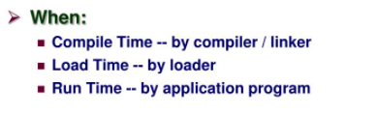

QUESTION: FEW EXAMPLES OF HIGH-LEVEL LANGUAGE?

Examples of high-level programming languages in active use today include **Python**, **Visual** Basic, Delphi, Perl, PHP, ECMAScript, Ruby, C#, **Java** and many others. The terms high-level and low-level are inherently relative.

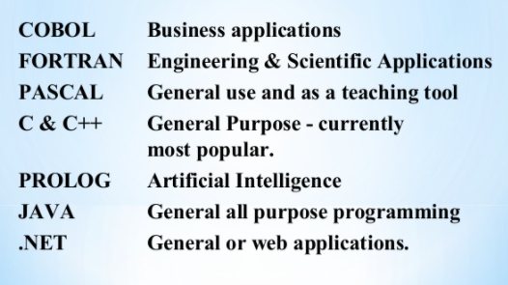

**THE END**